**Planet Heat – Project Report**

**1. Problem Definition**

Climate change is one of the most pressing global issues, with rising temperatures impacting ecosystems, agriculture, weather patterns, and human health.  
Accurate temperature predictions are essential for understanding climate trends, preparing for extreme weather, and informing policy decisions.  
Existing solutions often require advanced technical expertise, limiting accessibility for non-expert users.  
PlanetHeat addresses this gap by providing a **user-friendly, AI-powered platform** for accurate, real-time temperature prediction.

**2. Design Specifications**

PlanetHeat is a web application that:

* Uses **AI/ML algorithms** to predict future temperatures based on historical climate data.
* Provides **interactive visualizations** for better understanding.
* Features a **responsive and intuitive UI** for accessibility on all devices.

**Design Goals:**

* Easy-to-use input form for country, city, and date selection.
* Clear prediction results with chart.
* Modern UI with dark theme and responsive design.

**Technology Stack:**

* **Frontend:** HTML5, CSS3, Bootstrap 5, Plotly.js
* **Backend:** Python Flask
* **Machine Learning:** scikit-learn, pandas, numpy, matplotlib
* **Data Source:** Berkeley Earth Surface Temperature Dataset

**3. Diagrams**

**3.1 System Architecture Diagram**

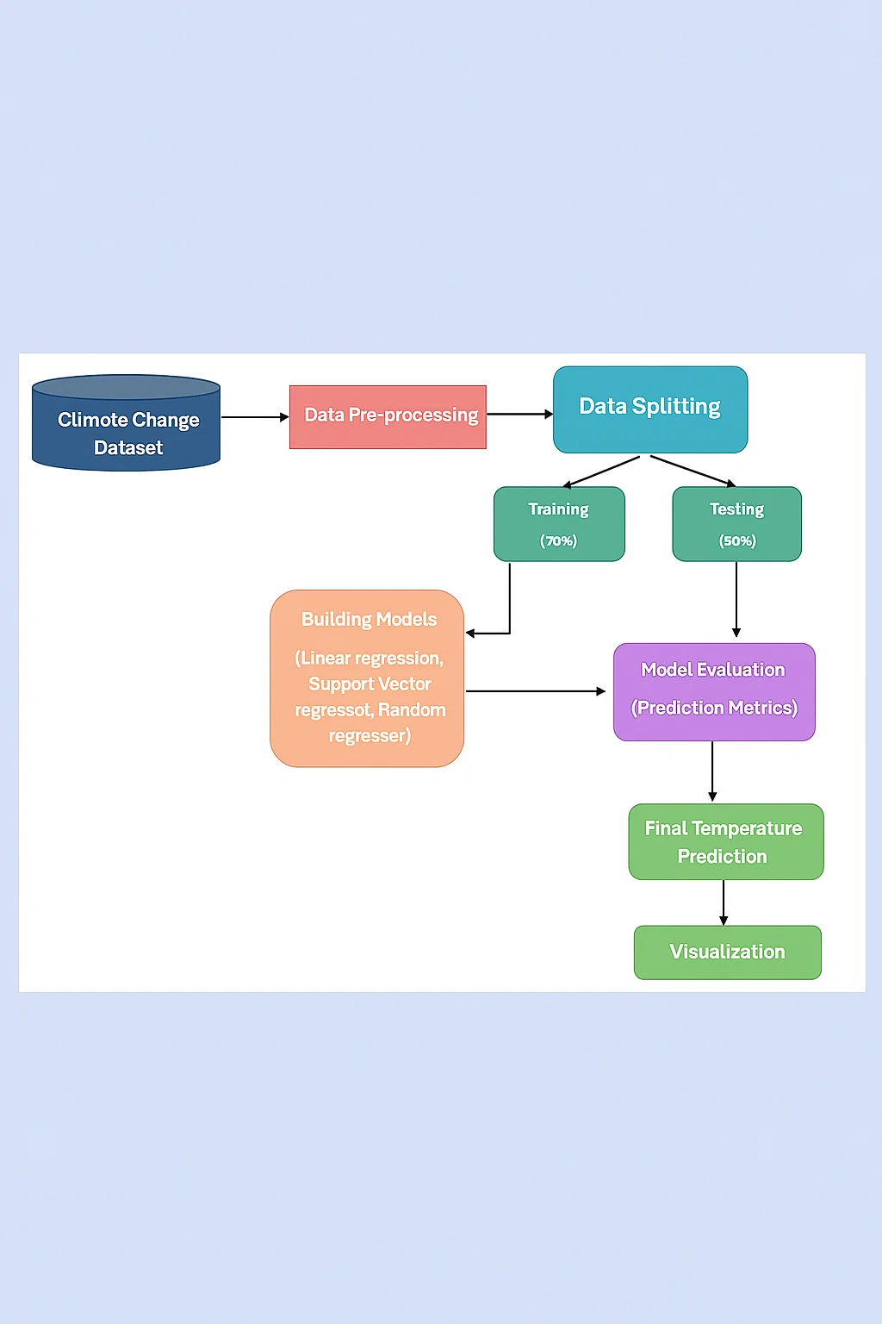

**3.2 Dialog Flow Diagram**

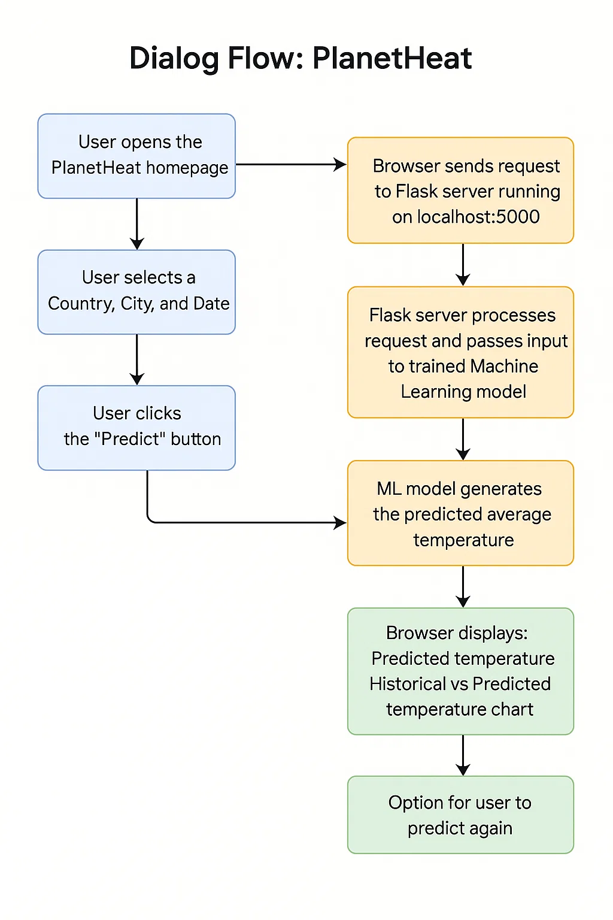

**4. Test Data**

A subset of the Berkeley dataset is used for testing purposes.  
Example:

| **Date** | **Country** | **City** | **Avg Temp (°C)** |
| --- | --- | --- | --- |
| 2000-01-01 | USA | New York | It will predict by the model |
| 2027-05-08 | Pakistan | Nawabshah | It will predict by the model |
| 2010-05-15 | Pakistan | Karachi | It will predict by the model |

**5. Project Installation Instructions**

1. **Clone the repository:**
2. git clone https://github.com/MaierAhmed/Planet-heat-temperature-prediction.git
3. cd planetheat
4. **Create virtual environment:**
5. python -m venv venv
   * Activate it : venv\Scripts\activate
6. **Install dependencies:**
7. pip install -r requirements.txt
8. **Run application:**
9. Python app.py
10. Open browser and go to:  
    <http://localhost:5000>

**6. Steps to Execute the Project**

1. Open the PlanetHeat homepage.
2. Select **Country** from the dropdown.
3. Select **City** (auto-populated based on country).
4. Select **Date** for prediction.
5. Click **Predict**.
6. View:
   * Predicted average temperature.
   * Historical vs Predicted trend chart.
7. Optionally, click **Predict Again** to make another prediction.

**7. GitHub Repository Link**

**Public Repo:**  
<https://github.com/MaierAhmed/Planet-heat-temperature-prediction.git>

**8. Published Blog**

**Blog Link:**  
<https://medium.com/@abbasimaier1/planetheat-ai-powered-climate-prediction-using-machine-learning-and-flask-25b4ce708bfd>

**9. Source Code & Notebooks**.

* HTML templates in /templates folder.
* Dataset files are in /data folder
* Trained model files are in /models folder
* Backend file is in the main folder (eg. app.py)
* All the dependencies are in requirements.txt
* .ipynb Jupyter Notebooks for:
  + Data preprocessing
  + Model training
  + Model evaluation
* Included in public GitHub repository.

**11. Conclusion**

PlanetHeat delivers a powerful yet simple solution for temperature prediction.  
By combining AI/ML techniques with an accessible UI, it empowers users — from climate researchers to farmers — to make informed, data-driven decisions for a sustainable future.